Employee Data Breakdown

By:Yaman Dawod

Table of Contents:
Cover Page 1
Table of Contents: 2
Table of figures 3
Employee data clean up and changes 4
Age and salary by department/ business unit 5
Average annual salary by age group per department 6
Ethnicity age and salary by department 7
Employee count by ethnicity 8
Difference in employment male and female employees 9
Detailed breakdown of pay difference between male and female employees 10

Table of figures
Table 1 Information of highest paid employee 4
Figure 1 5
Figure 1.1 Average age by department
Figure 1.2 Average salary by department
Figure 2
Figure 2.1 Average age by business unit
Figure 2.2 Average salary by business unit 6
Figure 3
Figure 3.1 IT
Figure 3.2 Finance
Figure 3.3 Sales
Figure 3.4 Accounting
Figure 3.5 Human resources
Figure 3.6 Marketing
Figure 3.7 Engineering
Figure 4 Maximum and minimum age by ethnicity 7
Figure 4.1 IT
Figure 4.2 Finance
Figure 4.3 Sales
Figure 4.4 Accounting
Figure 4.5 Human resources
Figure 4.6 Marketing
Figure 4.7 Engineering
Figure 5 Median salary by ethnicity
Figure 6 8
Figure 6.1 Employee count by ethnicity
Figure 6.2 Employee count by country
Figure 6.3 Employee count by ethnicity per country
Figure 7 Difference between male and female employees 9
Figure 7.1 Employee count
Figure 7.2 Average annual salary
Figure 8 Average annual salary by gender by department 10
Figure 8.1 IT
Figure 8.2 Finance
Figure 8.3 Sales
Figure 8.4 Accounting
Figure 8.5 Human resources
Figure 8.6 Marketing
Figure 8.7 Engineering
Figure 9 Average annual salary by age group by gender
Figure 9.1 Accounting
Figure 9.2 Marketing
Figure 9.3 Human Resources
Figure 9.4 Engineering

To start we have found 18 employees with missing data in the spreadsheet, they have been grouped together in a separate spreadsheet and will not be considered in the data analysis as their data might be flawed.
Changes to data:
- Changed employee Emily Davis’s name (E02387) to Emily David as the original last name was a typing error
- Normalized bonuses for employees E04105 and E02572 from 0% and 20% respectively to 10% each
- Increased pay of employee E02832 from 84,913 to 85000
- Decreased pay of employee E01639 from 95,409 to 95000

The highest paid employee:

EEID | E04354
Full Name | Raelynn Rios
Job Title | Vice President
Department | Sales
Business Unit | Manufacturing
Gender | Female
Ethnicity | Latino
Age | 43
Hire Date | 2016-08-21
Annual Salary | 258,498.0
Bonus % | 35%
Country | United States
City | Columbus
Exit Date | NaT
_{Table 1}

Breakdown of average age and salary by department:
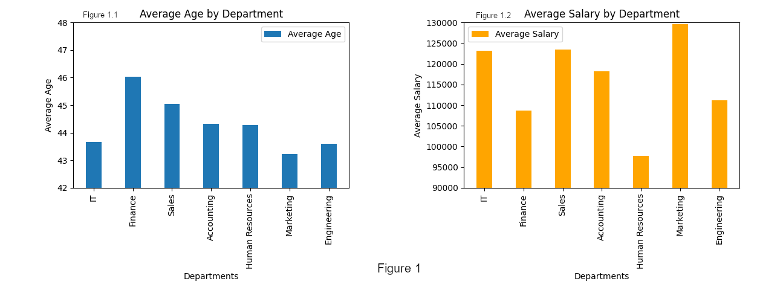
The youngest employees tend to work in IT, marketing, and engineering. While finance and sales employees are the oldest.

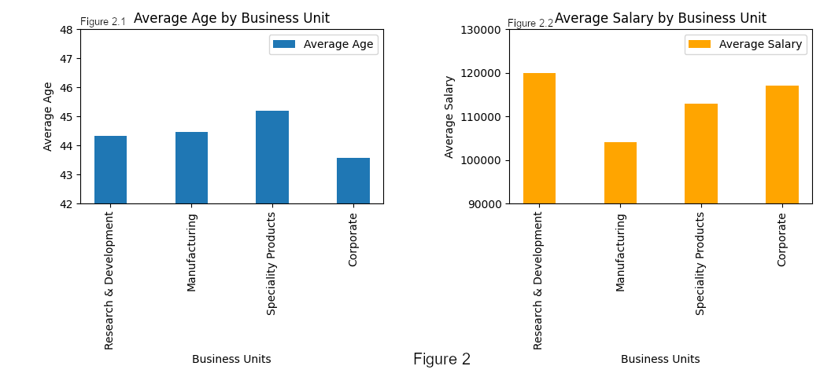
Breakdown of average age and salary by business unit:
The difference between business units in average age is relatively small. Even in average annual salary with the exception of manufacturing which has the lowest average salary by a significant amount.

Breakdown of the average annual salary by age group:
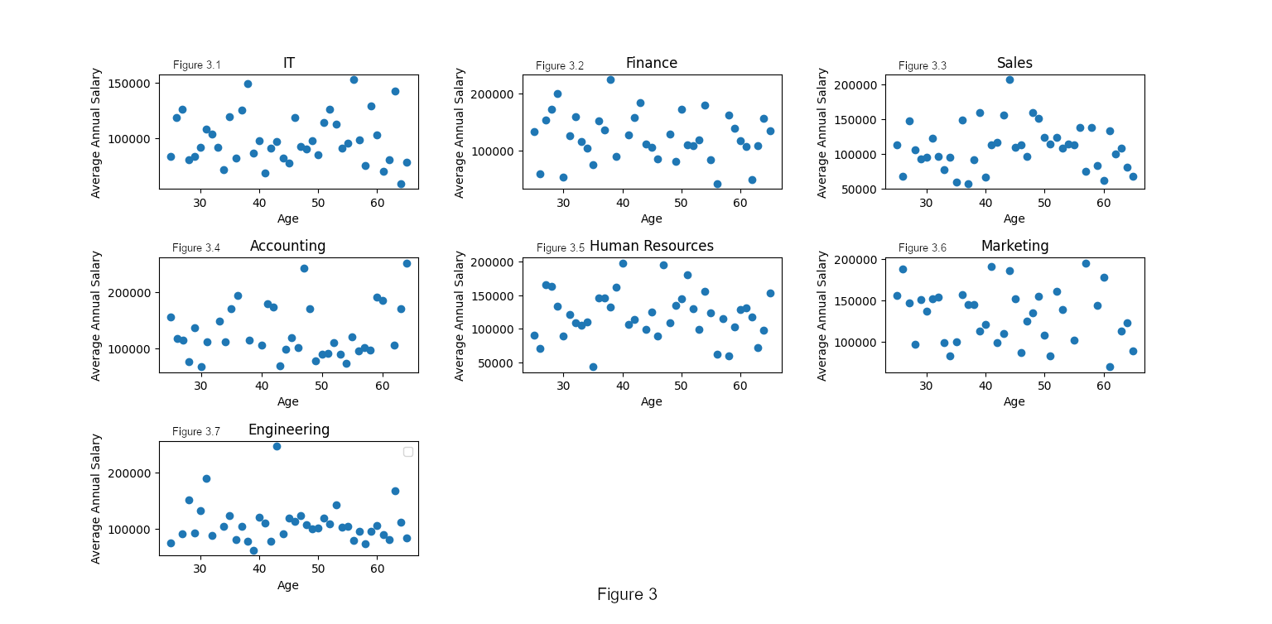
There is no bias towards any age group in terms of higher or lower annual salary, this could indicate a lack of improvement in pay with time or a high potential for younger employees to reach higher salaries earlier in their careers.
Breakdown of the maximum and minimum age and median salary by ethnicity per department:
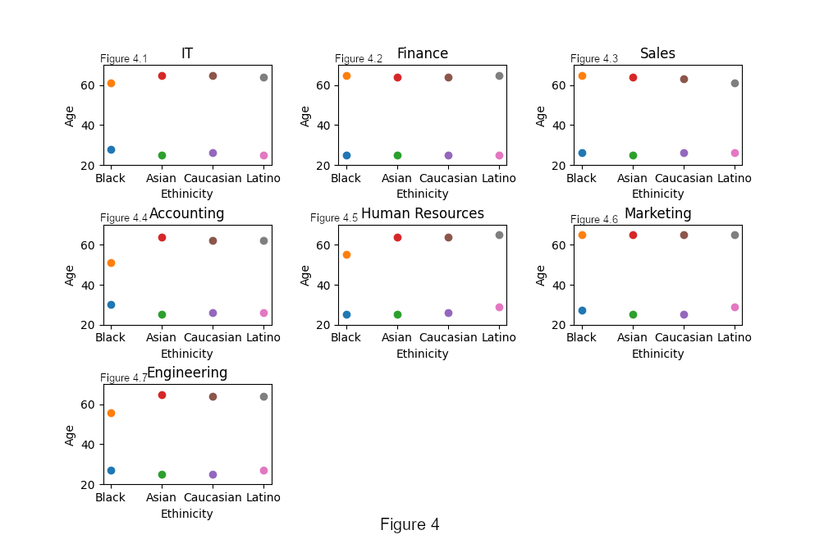
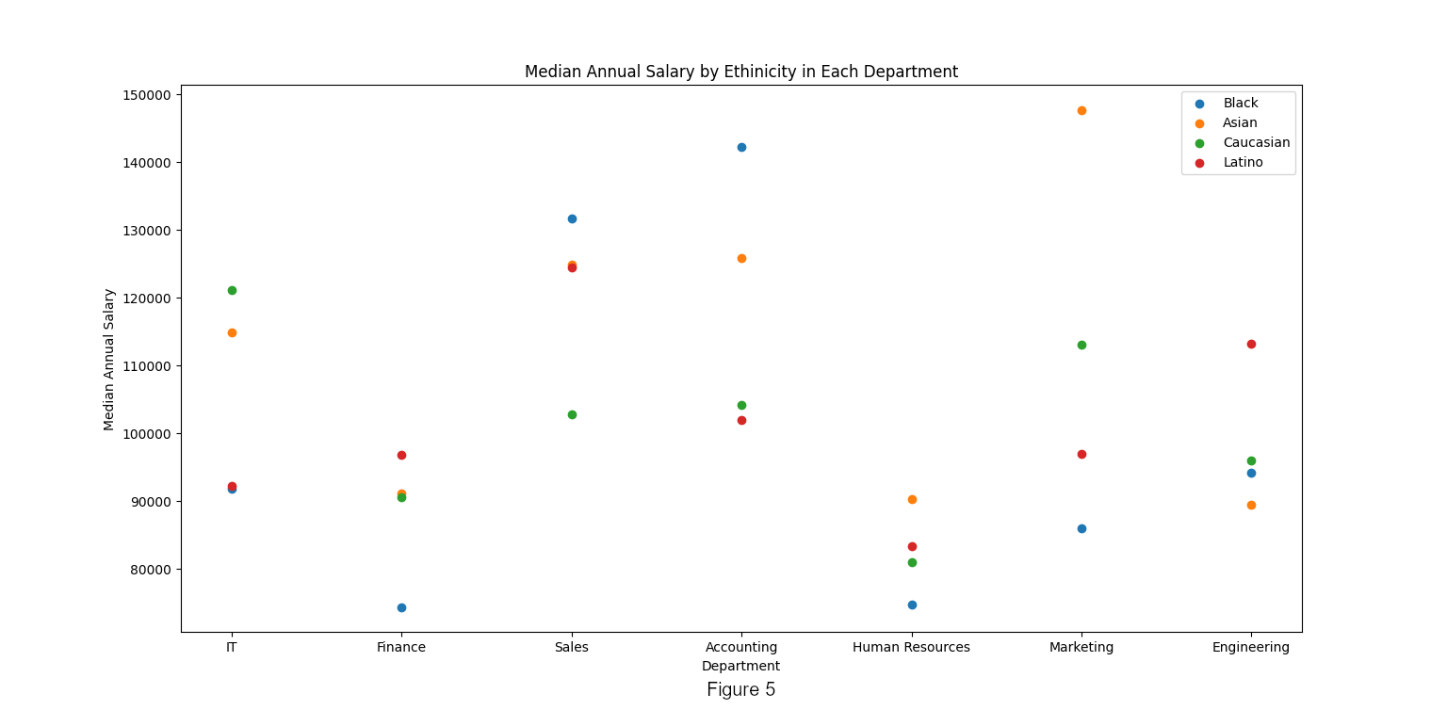
Most ethnicities’ maximum and minimum ages do not vary much from other maximum and minimum ages except black employees in accounting, engineering and human resources, this is a result of the company having less black employees than any other ethnicity as shown in the figures next page.

In almost every department there is a significant difference in average annual salary between the highest average salary and lowest per ethnicity. The worst offenders are accounting and marketing with the highest average per ethnicity being 31.9% and 71.7% higher than the lowest annual average respectively.
Breakdown of employee count by ethnicity and country:
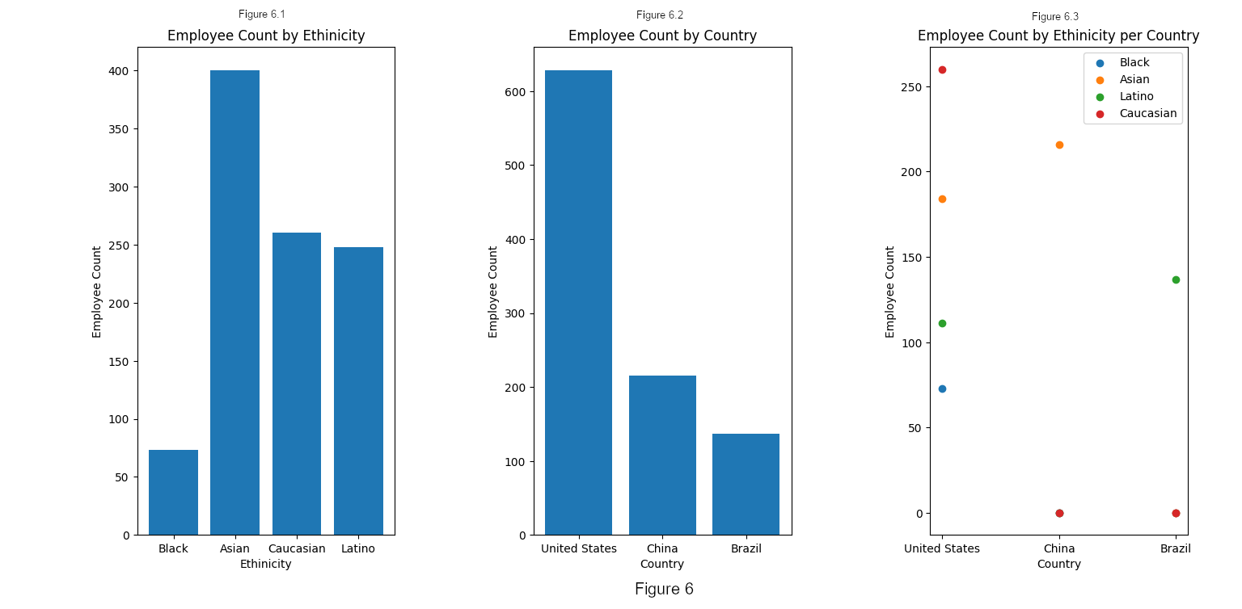
The left most bar graph shows that black employees are employed the least, the right most graph shows that all black employees are employed in the United States, and the graph in the middle shows that a majority of our employees are employed in the United States. Since most of the employees are in the United States and black employees make up $\frac{73}{628}=11.6\%$ of our United States based employees and $\frac{73}{981}=7.4\%$ of our global employees this shows a significant issue in diversity within the company.

Other information from the figure: 400 of the company’s employees (40.7%) are Asian, 216 of which are situated in China and 184 situated in the United States. Caucasian and Black employees are only situated in the United States. Employees hired in China are exclusively of the Chinese ethnicity and employees hired in Brazil are exclusively of the latino ethnicity. The United States is the only country where we operate that employs more than one ethnicity and it includes all ethnicities we are hiring currently (Asian, Black, Caucasian, and Latino).
Breakdown of the difference in pay between male and female employees in the company:
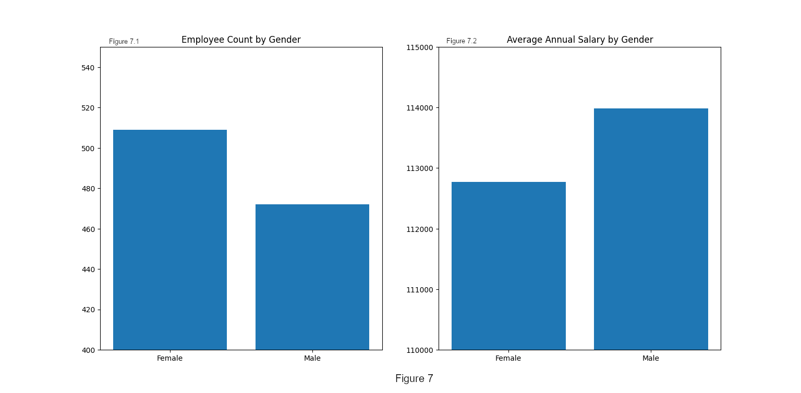
The amount of female employees is over 7.8% that of the male employees. There is also a significant difference in average annual salary between male and female employees, which shows room for improvement, the difference is well below the average company in the USA and EU.

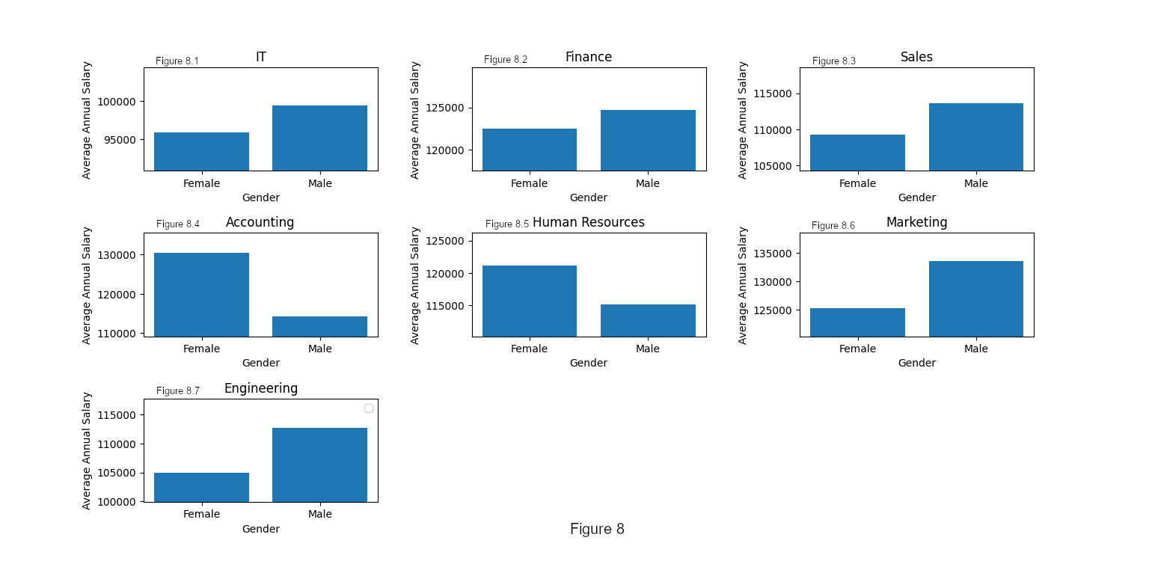
Employee average annual salary by gender per department::

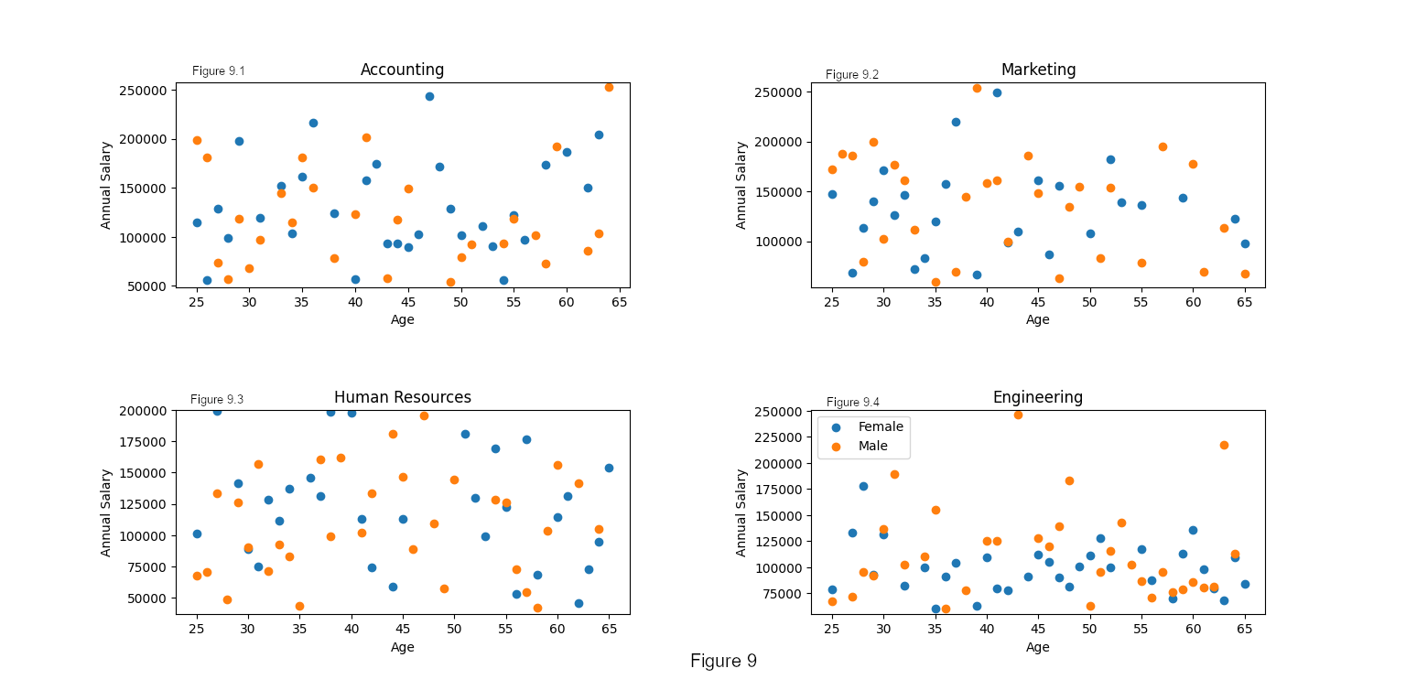
This breakdown shows that while female and male employees appear close in the overall company female employees are paid less by anywhere from 1.84% to 7.45% than male employees, but the pay difference seems slight over the whole company because in accounting and human resources female employees are paid 14.29% and 5.25% more than male employees respectively. Looking at the worst offending departments (accounting, human resources, marketing, engineering) in the next figure the pay difference can be attributed in all of these cases to the concentration of the highest paid employees. In accounting and human resources the amount of female employees at the top half (top tenth for human resources) of the graph is multitudes higher than male employees, a similar effect in the opposite direction can be seen in the engineering and marketing departments, where the higher paid employees are mostly male.

